# Design Overview for Console ATM

Name: Luong Trac Duc Anh

Student ID: 103488117

# Summary of Program

This program will mimic the functionalities of a real-life ATM, showing the main menu to insert your ATM card and log in via a 6-digit PIN. After you have successfully logged in, a secure menu will show up with 4 options: Check balance, Place deposit, Make withdrawal and Logout.

* **Check balance** will print the current money amount you have on your ATM card to the screen.
* **Place deposit** will allow you to insert an amount of money (up to your choice) into the account, and your balance will also increment with that number, starting from the initial that the program run. After that, the program will display your current balance number.
* **Make withdrawal** will allow you to cash out an amount of money (up to your choice but has to be within the account’s current balance). Next, your balance will also decrease based on the amount of money that you have drawn. After that, the program will display your current balance number.
* **Logout** will exit your account and return to the main screen, with 2 options: Insert ATM Card or Exit.

Sketch:

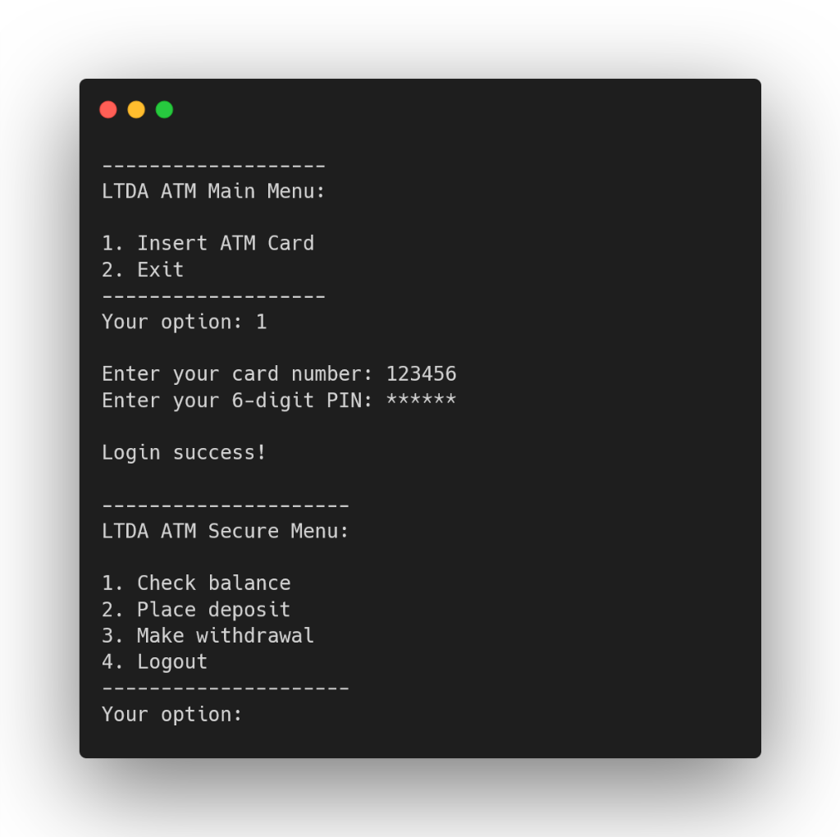

# Required Roles

Table : <<role name>> details – duplicate

|  |  |  |
| --- | --- | --- |
| Responsibility | Type Details | Notes |
| currency | String | Contains the currency used for this ATM (AUD) |
| currentAccountAmount | double | The balance amount that will be updated after each transaction (deposit, withdrawal) |
| showMainMenu() | void | Shows the menu for a card insert |
| showSecureMenu() | void | Shows the menu to check balance, withdraw money, and make a deposit |
| printNewBalance() | void | Prints the balance after each transaction |
| validateInput() | bool | Calls the TryParse() method |
| passValidation | bool | Is set to false initially will return true if the number input is in the correct format |
| myInt | int | The integer value used to pass in validateInput() |
| placeDeposit() | void | Adds the user’s inputted deposit amount to their bank account |
| depositAmount | double | Holds the deposit value that the user inputted |
| makeWithdrawal() | void | Subtracts the user’s inputted withdrawal amount to their bank account |
| withdrawAmount | double | Holds the withdraw value that the user inputted |
| minimumBalance | double | Will be set to 10 AUD; the user cannot withdraw an amount that makes their balance falls below this number |
| checkPassword() | void | Validates the user’s inputted card number and PIN code. |
| pass | bool | Sets to false initially, will return true if the card number and PIN code match the given Dictionary |
| myUserList | Dictionary  <int, int> | Adds card number and PIN code |
| mainOperation() | void | Executes the program based on the user’s inputs and calls the aforementioned functions |
| Main() | void | Calls the mainOperation() method |

Table : <<enumeration name>> details

// No enumeration needed for now

|  |  |
| --- | --- |
| Value | Notes |
|  |  |